**WEDNESDAY**

**.**

**SHARE NEW SINGLE “**[**ELDERBERRY WINE**](https://wednesday.lnk.to/elderberry-wine)**”**

**MAKE THEIR TELEVISION DEBUT TONIGHT ON**

**THE LATE SHOW WITH STEPHEN COLBERT**

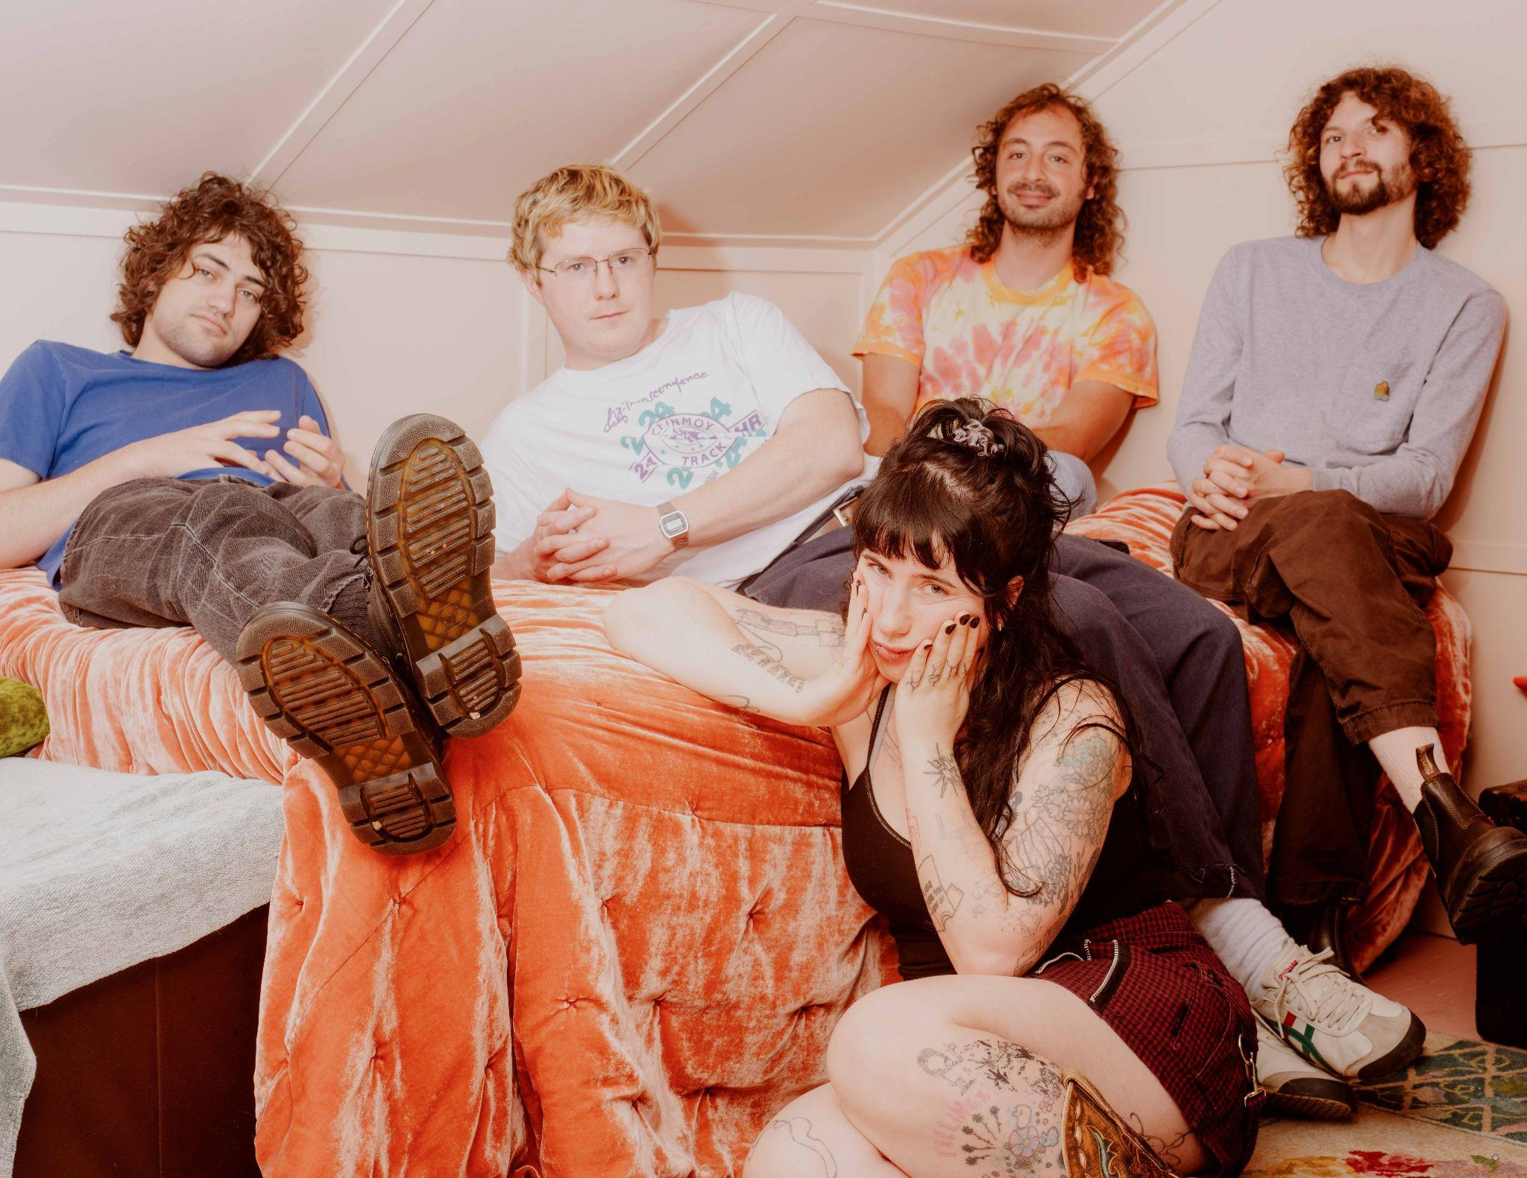

**Photo Credit: Graham Tolbert (**[**download hi-res**](https://drive.google.com/file/d/19RBQDKLnmFYDPmaKgad0v7ervh9Y-tKZ/view?usp=drive_link)**)**

**Wednesday**, the North Carolina rock band led by generational songwriter Karly Hartzman, share a twangy and timeless new single titled “[**Elderberry Wine**](https://wednesday.lnk.to/elderberry-wine),” alongside a video directed by Spencer Kelly.

“‘Elderberry Wine’ is about the potential for sweet things in life (love, family, success) to become poison if not prepared for and attended to correctly,” *Hartzman explains.* “Elderberry is known as a healing fruit, and is an ingredient in many tonics and syrups to aid the immune system. One time however, my sister consumed them raw and it immediately induced vomiting. So ‘Elderberry Wine’ is ultimately a love song about creating just the right environment for fulfillment. There's a delicate balance that needs to be created, especially in love, for two lives to intersect without poisoning each other.”

Wednesday will perform the track and make their awaited television debut tonight on The Late Show with Stephen Colbert. The show airs at 11:35pm ET/10:35pm CT on CBS.

“Elderberry Wine” is the first taste of new music from Wednesday since the release of their breakthrough album *Rat Saw God*. The album was one of 2023’s most critically acclaimed releases, landing on year end lists at the *New York Times, NPR, Pitchfork, Rolling Stone, Associated Press, Wall Street Journal, LA Times, The Altantic, The Ringer, The FADER, Paste, Consequence, Stereogum* and more.

Wednesday is Karly Hartzman, MJ Lenderman, Xandy Chelmis, Alan Miller, and Ethan Baechtold.

**WATCH THE “**[**ELDERBERRY WINE**](https://youtu.be/uE0waEdE2Pw)**” VIDEO**

[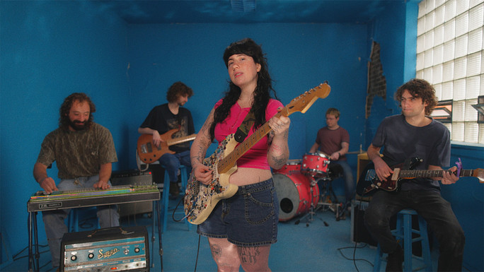](https://youtu.be/uE0waEdE2Pw)

Of the video, director Spencer Kelly says *“*We shot most of this music video at The Bench, Greensboro's second-oldest bar and easily one of its most vibrant. On any given day, you’ll find people there from all walks of life swapping stories beneath the music blasting overhead. We came in with some specific scripted scenes, but we wanted to capture the bar as authentically as possible—so everyone you see in the video is a regular, including Karly’s dad, George. This video is a bit of a love letter to places like this, where the sense of community runs deep and the beers are always cold.”

**Praise for Rat Saw God:**

“One of the best indie rock bands around.”

***-Pitchfork, Best New Music***

"An exceptional record that makes you want to look more deeply at the world around you, an album of wild storytelling and quiet epiphanies."

***-The Wall Street Journal***

“A beautifully bleak record that spins up country, shoegaze, suburban nightmares and youthful debauchery into a thrilling work of distorted Americana.”

***-NPR***

"Rat Saw God is a rare Great Unifier; anyone who has identified as an indie rock fan in the past 30 or so years will find something to love here."

***-The Ringer***

“Wednesday falls somewhere between the country rumbling of the Drive-By Truckers and the melodic squeal of early Dinosaur Jr.”

***-The New Yorker***

“Wednesday might end up as the greatest indie band of their generation.”

***-Stereogum***

"What makes Wednesday one of the best bands in the world is Hartzman’s songwriting. It’s paradisiacal in a scuzzy way, adaptable to any underbelly in North America and wickedly unafraid of being too truthful or unabashed." ***-Paste***

“Karly Hartzman’s storytelling remains a beautifully magpie-like collection of little details drawn from memory and observation, woven together into a transcendent indie rock tapestry.”

***-The AV Club***

**TOUR DATES:**

7/26-7/27 - Portland, OR @ Project Pabst

10/10-10/12 - Las Vegas, NV @ Best Friends Forever

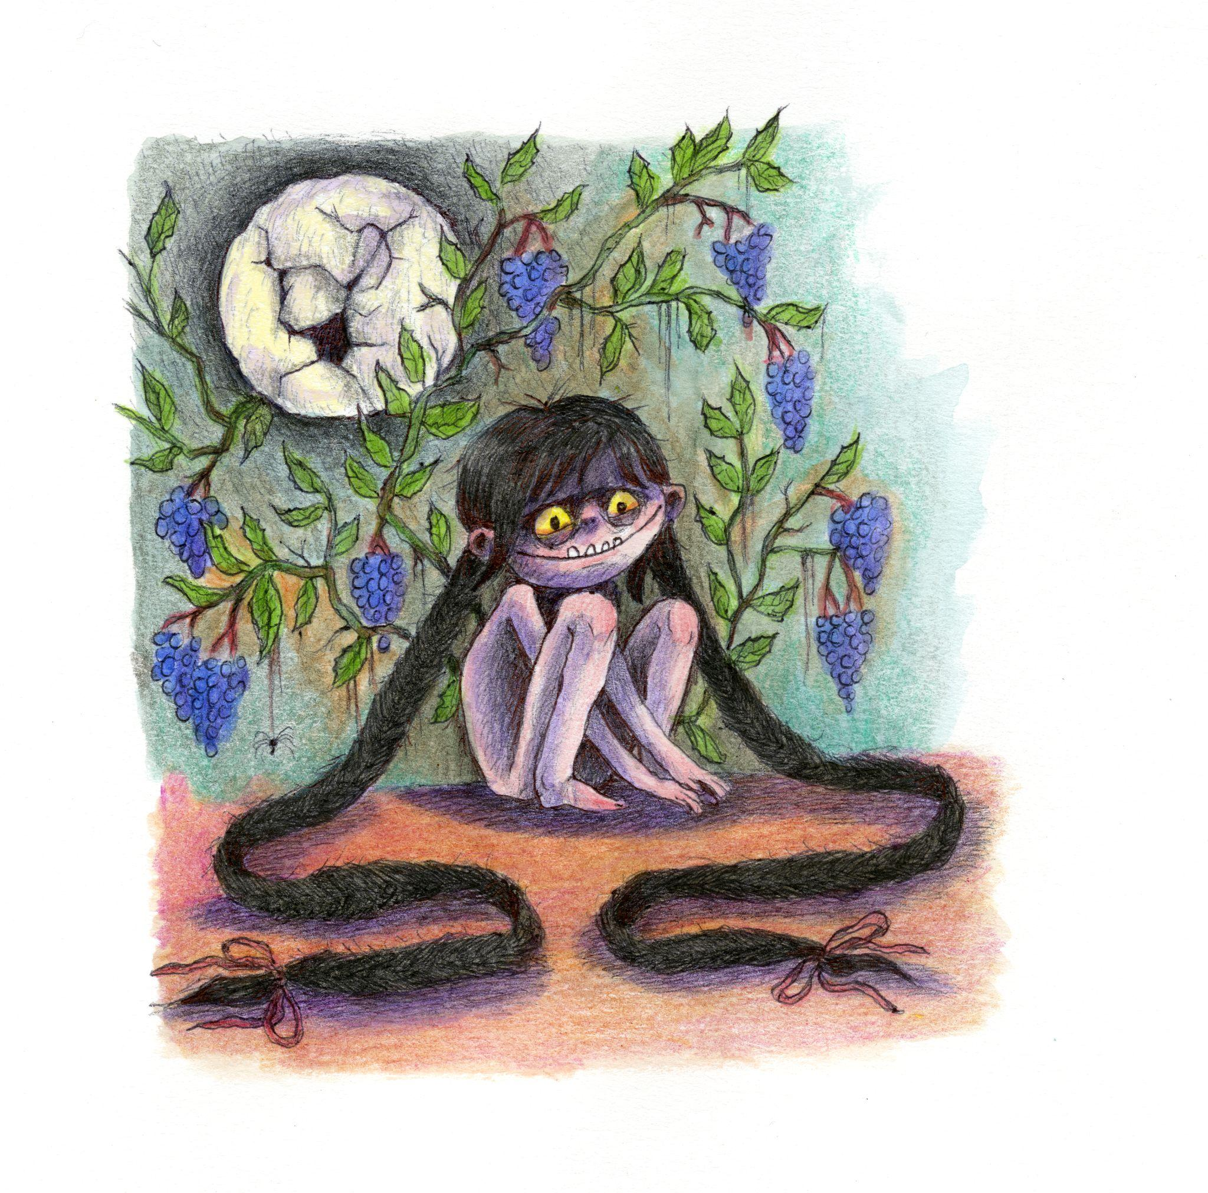

**Single Art Credit: Kamila Mlynarczyk (**[**download hi-res**](https://drive.google.com/file/d/1I2O2H0O_1Pio28jNhablTFl-IgipjMeJ/view?usp=drive_link)**)**

[**Website**](https://www.wednesday.band/) **|** [**Bandcamp**](https://wednesdayband.bandcamp.com/)**|** [**Spotify**](https://open.spotify.com/artist/4j7DrazfBZLLD0OrVoAtEe) **|** [**Twitter**](https://twitter.com/Wednesday_Band_?ref_src=twsrc%5Egoogle%7Ctwcamp%5Eserp%7Ctwgr%5Eauthor) **|** [**Instagram**](https://www.instagram.com/wednesday_gurl/?hl=en) **|** [**Facebook**](https://www.facebook.com/WednesdayTheBand/)

**For more information please contact Grandstand Media & Management:**

**Eloy Lugo**