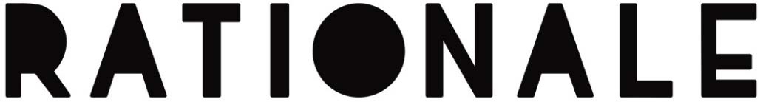

SELF-TITLED DEBUT ALBUM TO BE RELEASED ON OCTOBER 6TH

ALSO SHARES BRAND NEW TRACK ‘LOVING LIFE’ – LISTEN HERE: ADD LINK

“This person has discovered beauty in their voice” – Pharrell Williams

“There’s no easy comparison for his voice, a mountainous baritone that could make him the most remarkable new singer since Sam Smith.” – Evening Standard

“Rationale has been killing it left, right and centre.” – Pigeons & Planes

“Rationale’s rich baritone is one of the most distinctive out there.” – The Line Of Best Fit

“Powerful, stirring, and honest songwriting.” – Clash

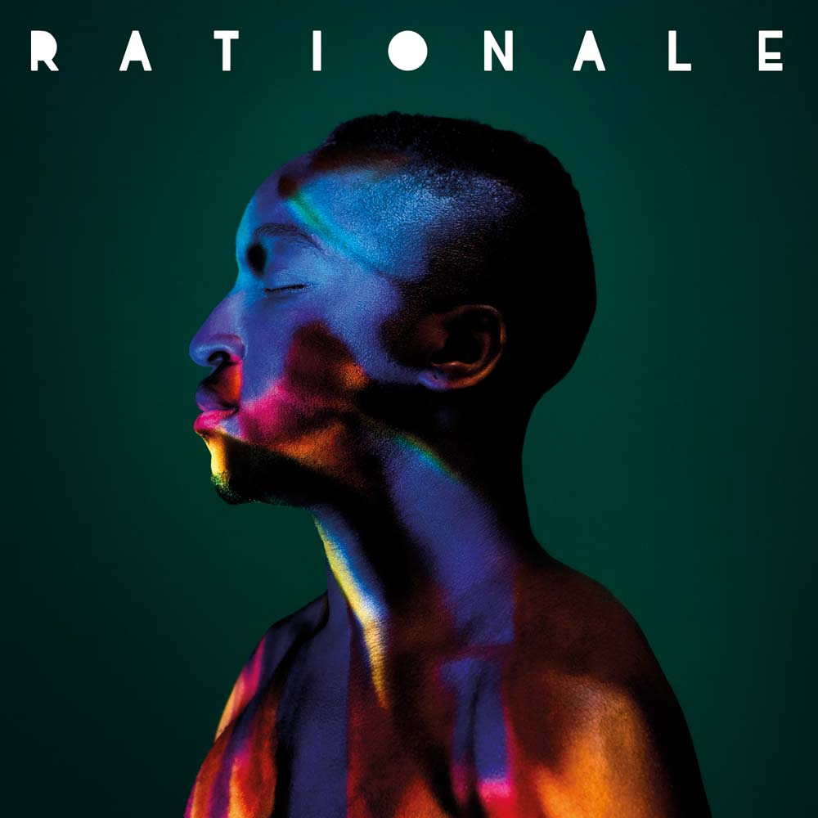

Possessing a gift for songwriting which allows him to push the boundaries of R&B, pop and soul while also presenting an intriguing worldview in his lyrics, RATIONALE has become an in-demand collaborator. Rag’n’Bone Man (‘Wolves’, ‘Guilty’ and ‘Life In Her Yet’), Katy Perry (‘Act My Age’) and Nause (‘Dynamite’) have all called on his talents, while further endorsements have included Ellie Goulding, who often covers his track ‘Tethered’ in her live shows, and Bastille, who invited RATIONALE to join them on their European arena tour.

Now RATIONALE presents his own artistic vision with the October 6th release of his self-titled debut album. It features select highlights of his career to date – including the 14 million-streamed smash ‘Fast Lane’, the towering live anthem ‘Deliverance’ and the emotional intensity of ‘Prodigal Son’ – alongside a wealth of new material.

The album is launched with the brand new track ‘Loving Life’, a continually evolving production of playfully unpredictable beats, dominant bass and swirling synths which allows RATIONALE’s evocative vocal gift to shine through. It also demonstrates his wide-ranging talents too, with a one-man masterclass of vocals, production and all instrumentation.

“’Loving Life’ was inspired by the arrival of summer and the idea of making memories with people closest to me,” says RATIONALE. “I was really into 2-step garage as a kid and I wanted to pay homage to that era and make something that people could really dance to.”

‘Loving Life’ is just one of the inspiring new tracks which are set to be discovered on the album. Other highlights include ‘Oil and Water’ – a sumptuous blend of dramatic pop dynamics, modernist production embellishments and a foot in tradition with gospel-inspired vocal harmonies – and the percussive march of ‘Phenomenal’, which finds RATIONALE’s tender, emotive phrasing conveying a revealing fragility.

The majority of the album was produced by RATIONALE while Canadian producer Stint, whose credits include Gallant and Nao, worked on ‘Tumbling Down’.

RATIONALE’s debut album is now available to pre-order from ADD LINKS HERE. It will be available on download, streaming services, CD, vinyl and a limited edition signed vinyl that will be available exclusively from Amazon.

RATIONALE – real name Tinashé Fazakerley – is a Harare-born, London-based musician whose powerful live show has allowed him to prosper under the radar. The continual upscaling of his London shows is indicative of an artist able to use word-of-mouth to build a devoted following. After debuting at the intimate Courtyard Theatre, word of RATIONALE’s talents spread to the extent that he sold-out both Heaven and the 1500 capacity Electric Brixton just weeks apart early in 2017.

It’s a skill that’s held him in good stead for a wide array of leading festivals (Glastonbury, Secret Garden Party, Reading and Leeds, Latitude, Longitude, Barn On The Farm and more) as well as his first sold-out Stateside shows in New York, Los Angeles, San Francisco and Chicago. He’s already exceeded 34 million Spotify streams and 100,000 track sales in the UK before even releasing an album.

The album tracklisting is:

- ‘Re.Up’
- ‘Oil and Water’
- ‘Loving Life’
- ‘Fast Lane’
- ‘Prodigal Son’
- ‘Losing Sleep’
- ‘Into The Blue’
- ‘Living On The Line’
- ‘Phenomenal’
- ‘Deliverance’
- ‘Tumbling Down’
- ‘Somewhere To Belong’

RATIONALE will follow the album’s release by embarking upon a UK headline tour in October. He’ll play:

15th – Leeds, Brudenell Social Club
17th – Glasgow, Oran Mor
18th – Newcastle, The Cluny
19th – Manchester, Sound Control
22nd – Portsmouth, The Wedgewood Rooms
24th – Birmingham, The Hare and Hounds
25th – Brighton, The Haunt
26th – London, Electric Ballroom

https://open.spotify.com/artist/2IQDM5URYGYfSMmwhTCmyy
https://www.facebook.com/iamrationale/
https://twitter.com/iamrationale
https://soundcloud.com/iamrationale
https://www.youtube.com/user/rationaleVEVO/

For more information please contact paul.guimaraes@warnermusic.com

